CS4121 Assignment 3 Due: 09/14/17
Problem 1

(6 points) This is an experimental project on DNS.

The useful dig tool available on UNIX and Linux hosts is often used by the DNS administrators to explore the hierarchy of DNS servers and troubleshoot DNS problems. For this problem, you may either use your own computer running UNIX/Linux/Mac OS if you have one, or use the gargamel.valdosta.edu server, or use cloud 9 (See Problem 2 below).

First, man the dig command to get familiar with its options. Then, starting with a root DNS server (from one of the root servers [a-m].root-servers.net), manually initiate a sequence of queries for the IP address of gaia.cs.umass.edu. Show a list of names of DNS servers that you choose (one per each level on the DNS hierarchy return by one DNS query command) in the delegation chain in answering your query.

Note: you cannot use >dig +trace gaia.cs.umass.edu because that command will automatically choose all the DNS servers for you. You need to make your own choices.

Answer: IP address of gaia.cs.umass.edu = ? (e.g. x.y.z.w)

List of the specific DNS servers that you used: ?
(
e.g. ?.root-servers.net
?.edu-servers.net
?.umass.edu
)

Justify your answers by attaching screenshots of the terminal with all your dig queries and their results. One screenshot per dig command please.

Screenshots:

Problem 2

General Description

(19 points) This is an experimental project on WebSocket.

In order to focus on the WebSocket protocol itself rather than being overwhelmed by the details of the installation, configuration, development, and deployment of the experimental environment, we are going to use an off-the-shelf demo project from Cloud 9 (https://c9.io) – an online code editor with a full Ubuntu workspace in the cloud.

Note: If your firewall blocks you from visiting Cloud 9, you might have to open it in an incognito window in your browser.
Experimental Environment

- Create an account on Cloud 9 if you don’t have one yet.
Note: If you already have an account either at Github or Bitbucket, you may simple login with your Github/Bitbucket credential without creating a new Cloud 9 accout.
- Log into Cloud 9, create a new workspace, name it yourfirstname-yourlastname- cs4121-a3, make sure to select “Node.js” as the template, and click “Create workspace”.
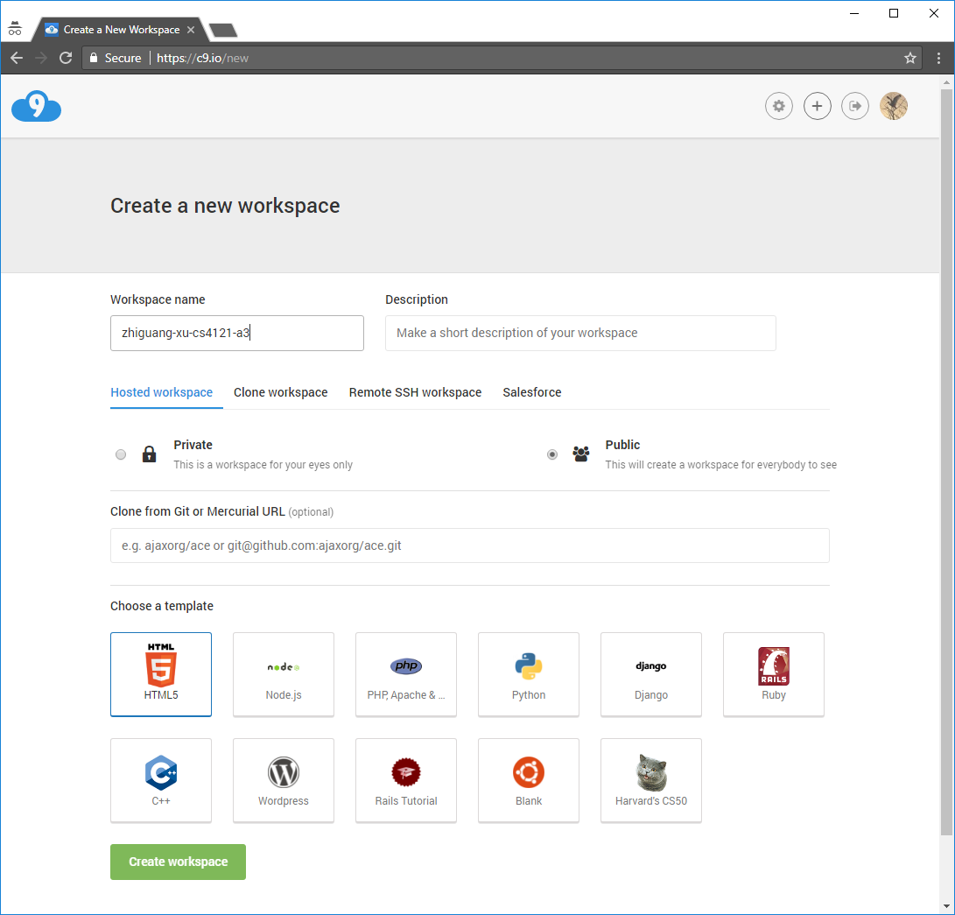

- Open server.js – a Node.js based chat server using popular libraries including Socket.IO, Express, and Async.
Open client/index.html – a chat client using JavaScript frameworks such as Socket.IO, AngularJS, and jQuery.
In the terminal window, type the command node server.js to start the chat server.

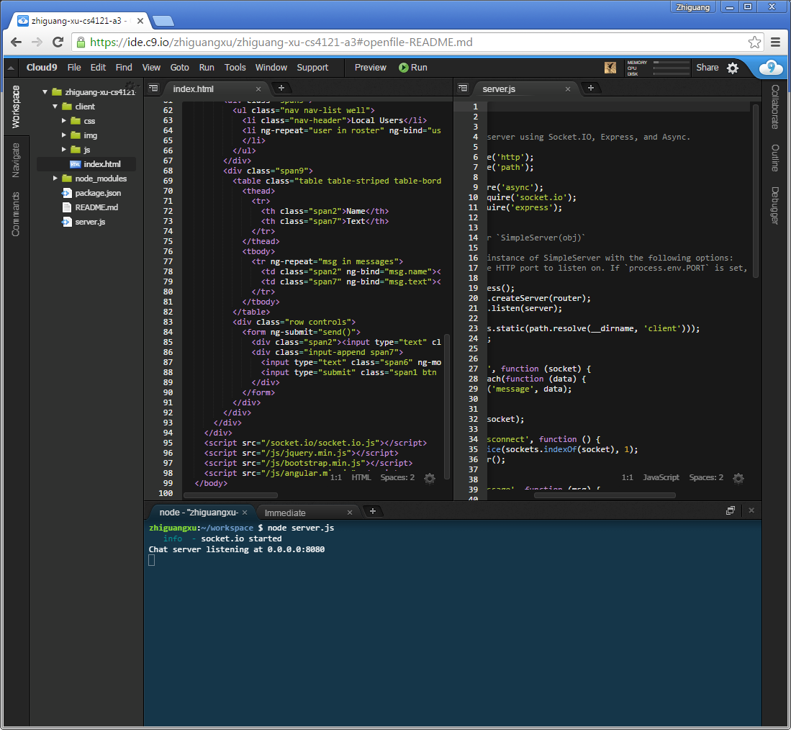

- Click Share to open the “Share this workspace” window, click the Application URL, then choose “open” at least two times to open at least two chat clients in your browser. Although all modern browsers should work, please use Google Chrome. Close the “Share this workspace” window.

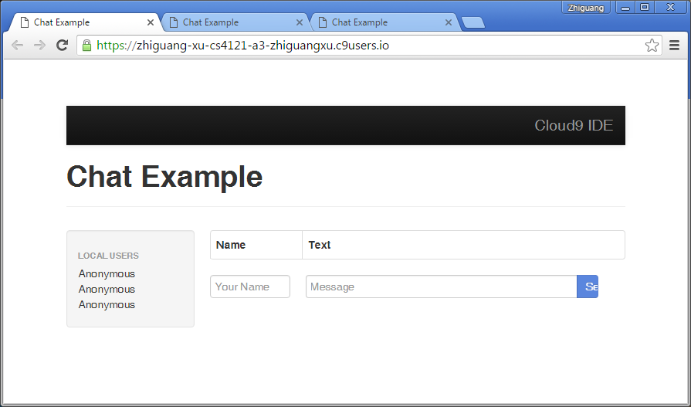

- In each chat client brower window, open the developer tools, click Network, select WS to display WebSocket messages/frames only, then refresh the chat client. Click the wss address under “Name”, you are all good to go to the next section.

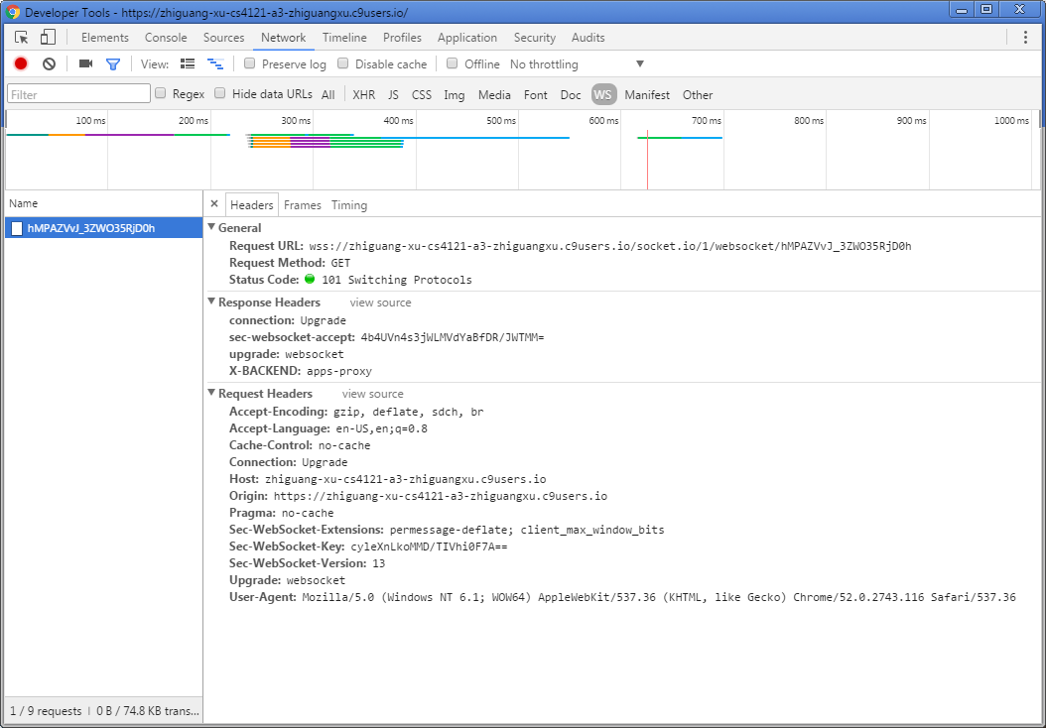

Experiments
Note: For each question below, you are asked to attach a screenshot to justify your answer. In each of such screenshots, use block arrows to stress the pertaining items.

- (2 points, 2 questions, please put each answer on a separate line) The client and server have to establish an HTTP connection through HTTP handshaking before any WebSocket communication starts. What type of HTTP request the client sends to the server? In the HTTP response from the server, what is the status code?

Answer:

Screenshot:

- (2 points, 1 question) When client and server are running the WebSocket protocol, the HTTP connection between them stays alive. To verify this, click the Timing tab in the developer tools window, take a screenshot of what you see, and attach it below.

Answer (describe what you see):

Screenshot:

- (5 points, 5 questions, please put each answer on a separate line) When a new client joins the chat, what is the name of the frame it sends to the server? In response, what is the name of the frame the server sends back? Does the server broadcast this frame to all existing clients? Who picks the default name “Anonymous” for this new client – the client itself or the server? How does the new client get all the chat texts (if any) currently on the server?
Hint: To answer this question (i.e. a new client joins the chat), you could just refresh one of the existing chat clients. Also, it is going to be helpful for you to read the code on both the client and the server sides.

Answer:

Screenshot:

- (3 points, 1 question) As you can see, the default name for the chat client is “Anonymous”. If the client decides to change it to say “yourfirstname”, describe the frames exchanged back and forth between the client and server.
Hint: It is going to be helpful for you to read the code on both the client and the server sides.

Answer:

Screenshot:

- (2 points, 2 questions, please put each answer on a separate line) When the client sends a text to other clients through the server, what is the name of the frame it sends to the server? In response, what is the name of the frame the server broadcasts to all clients?
Hint: It is going to be helpful for you to read the code on both the client and the server sides.

Answer:

Screenshot:

- (5 points, 1 question) WebSocket is an open protocol that allows you to customize the name, format, and contents of the frames transmitted between the client and server. As a little practice, modify the code on both the client and server sides such that the name of the frames that carry the chat texts from what it is now to “cs4121_a3”. Restart the server and test it.
Answer: Not needed.
Screenshot:

What to turn in?

- This word document with all your answers and screenshots.

